Physics Stage 3: Particles, Waves and Quanta 2010

Test Two
Name: _____________________________________________________________ (48 marks)
- Absorption and emission spectra of gases in the atmosphere are line spectra rather than a broadband or continuous spectra. Explain why. (3 marks)

Lines correspond to discrete energies of electron jumps. (1 mark)
In absorption electrons jump to higher energy levels – these are discrete jumps up.
(1 mark)
In emission spectra electrons return to lower energy levels via discrete jumps
(1 mark)

- Some minerals will show colours under ultra-violet light. What is the name of this phenomena and how does it occur? Include a diagram with your answer. (4 marks)

Fluorescence. (1 mark)
Fluorescence is the phenomena where electrons in ground state within a substance (in this case the mineral) absorb energy of a certain wavelength and jump to a higher level.
(1 mark)

Electrons then cascades back to ground state via different levels emitting lower energy and longer wavelength. Certain of these wavelengths have frequencies of visible light so colour is seen in the rock. (1 mark)
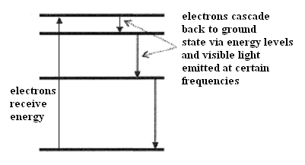

(1 mark)

- X-rays can be produced using a device similar to the one represented below. The labels on the diagram at A, B, C and D are missing. Write in the missing labels. (2 marks)
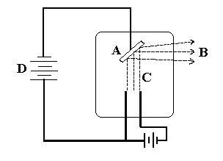
A: anode plate – metal target

B: X-rays

C: high speed electrons

D: high potential difference
- a. Consider the following statement. “The distances to different galaxies is proportional to red-shift of that galaxy with the more the red-shift, the further away the galaxy.” This
statement is know as Hubble’s Law (1 mark)

  - How does “red-shift” support the Big Bang Theory? (4 marks)

Redshift of light which is caused by the Doppler effect. (1 mark)

When an object is moving away from the observer, the wavelengths are increased.
(1 mark)
In light, this causes a shift towards the red end of the spectrum – hence red-shift.
(1 mark)
The red-shift of galaxies we observe show they are moving away from us which is evidence of a large explosion from a single point – the Big Bang Theory. (1 mark)

- The Big Bang theory predicts that the universe is expanding. Name and describe two possible futures for our expanding universe. (2 marks)

Open universe – in which the universe will keep expanding forever. (1 marks)
Closed universe – where the universe has a finite size and will stop expanding.
(1 marks)

NOTE:
This depends on whether there is enough mass for gravity to stop the expansion.

- Muons form when cosmic radiation hits air molecules high up in the Earth’s atmosphere. The average life expectancy of a muon before it decays is about 2.2 x 10⁻⁶ s and it can travel about 0.999 c (99.9 % the speed of light). Determine the distance a muon could travel within its lifetime. (2 marks)

s = v x t
= 2.2 x 10⁻⁶ x 0.999 x 3 x 10⁸ (1 mark)
= 660 m (1 mark)

- Consider the following example which helps to explain Einstein’s special relativity. Observer A is standing in the middle of a train which is travelling very fast. He presses a button which opens the front and back doors of the train at the same time. Observer B is standing on a platform watching the train go by. The diagram below shows this situation.

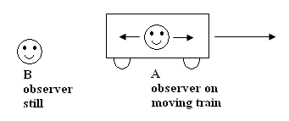

  - What does observer A see? A sees both doors open (1 mark)

  - What does observer B see? rear door opens first followed by front door (1 mark)
  - Who is right, A or B? Explain your answer. (2 marks)
Both are right. (1 mark)
One set of simultaneous events are not necessary simultaneous for another observer moving at different speed. (1 mark)

- Strong nuclear forces hold protons and neutrons together. Protons and neutrons are hadrons and each hadron is made up of three quarks. There are six types of quarks each of which has a fractional charge. Up-type quarks have a charge of +2/3 electric charge, while down-type quarks have -1/3 electric charge. If an electric charge is the charge on an electron, determine the quarks that make up a neutron and a proton. You must show your working to justify your answer.

- a neutron (2 marks)

neutrons are neutral so (+2/3) + (-1/3) + (-1/3) = 0
so an up + down + down

- a proton (2 marks)

protons have a charge of +1 so (+2/3) + (+2/3) + (-1/3) = +1
so an up + up + down

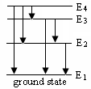
- A certain gas is composed of excited atoms. The diagram illustrates the energy levels available to the electrons (not including ionization level). How many lines would be in the full emission spectrum?

6 lines (1 mark)
Show in the diagram the transitions that give rise to these lines.
(1 mark)
- Fluorescent tubes contain low pressure mercury vapour whose atoms are excited by electrons travelling between the ends of the tube. Some of the energy levels of a mercury atom are shown to the right.
  - Determine the wavelength of photons produced when ground state electrons are excited to level E₄ and return to level E₁. (3 marks)

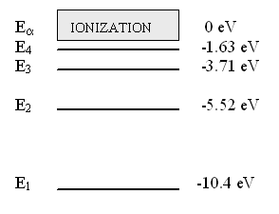

E₄ – E₁ = (10.4 – 1.63) x 1.6 x 10⁻
= 1.4032 x 10⁻¹⁸ J (1 mark)
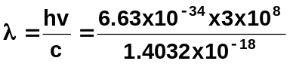 (1 mark)
λ = 1.42 x 10⁻⁷ m (1 mark)

- To what region of the electromagnetic spectrum do these photons belong? (1 mark)
Ultra-violet Radiation
- The term “ground state”, “excited state” and “photons” are used in part (a). What do each of these terms mean? (3 marks)

Ground state – all electrons in the atom are at the lowest energy level possible for that atom

Excited state – electron is at a higher level than ground state – has more energy

Photons – bundles of energy moving in a wave-like motion

Or similar depending on the definition you have taught your students.

- Ultra-violet Astronomy investigates energetic processes in stars and galaxies. This is because ultra-violet radiation has shorter wavelengths and more energy than visual radiation. An ultra-violet telescope is set up on a satellite to photograph an evolving galaxy.

  - Can an Ultra-violet telescope be set up on the ground? Explain. (2 mark)

No.
The Earth’s atmosphere and ozone layer is designed to limit the amount of UV radiation that hits the surface of the Earth therefore much information would be lost if astronomers tried to use a UV telescope on the Earth’s surface.

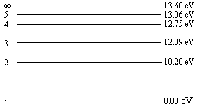
  - If the satellite records radiation with a wavelength of 9.75 x 10⁻⁸ m, between what two energy levels must the electron jump to produce this line? (3 marks)

ΔE = 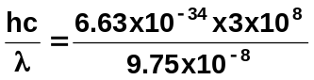 (1 mark)

ΔE = 12.75 eV (1 mark)

E₄ – E₁ = 12.75 eV

so the transition is from E₄ to E₁ (1 mark)

  - An electron is given 13.61 eV. What does this mean for the electron and what name do we give this process? (2 marks)

Ionisation (1 mark)
Electron has enough energy to leave the atom. (1 mark)

- a. A SHARP Carousel Microwave Oven model R480L has the following specifications:
- Output power = 1100 W
- Microwave frequency = 2450 MHz
- Depth with the open door = 860 mm
- Outside dimensions (WxHxD) = 550mm x 315mm x 446mm
- Cooking Uniformity = Turntable (φ320mm tray) system
The specification book for the microwave oven states that standing waves are set up in the oven. Show by calculation whether the specification book is correct or not. (3 marks)

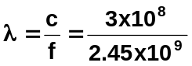 (1 mark)

λ = 0.122 m
= 122 mm (1 mark)

As the dimension are greater than this,
then a standing wave could easily be set up
within the microwave. (1 mark)

  - The magnetron which produces the microwaves in the oven causes photons to be emitted. How many photons are emitted each second by the magnetron? (3 marks)

P = 1100 W E = hf
= 1100 J / s = 6.63 x 10⁻³⁴ x 2.45 x 10⁹
E = 1.6244 x 10⁻²⁴ J for each photon (1 mark)

No. of photons = 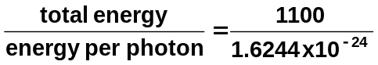 (1 mark)

No. of photons = 6.77 x 10²⁶ photons (1 mark)

